Unveiling market insights: Analysing spending Behaviour and identifying opportunities for growth
introduction
it seems like you're looking to discuss unveiling market insights, analyzing spending behaviour, and identifying opportunities for growth.
1.1.Overview
Analysing market insights involves studying consumer spending behaviour identifying trends and pinpointing potential areas for business growth. This includes studying purchasing patterns, preferences, demographics and economic factories to inform strategies for market expansion and product/ service development. The goal is to uncover actionable insights that can drive successful business decisions and optimize marketing efforts.
1.2. Purpose
The purpose of unveiling market insights and analysing spending behaviour is to gain a deep understanding of consumer habits, preferences, and purchasing patterns. This knowledge allows business to identify trends, potential growth areas, and unmet needs in the market. By recognising these opportunities, companies can tailor their products, services, and marketing strategies to meet consumer demands effectively, improve customer satisfaction and ultimately drive business growth and profitability.
2 problem Definition & Design thinking
2.1 Empathy map

2.2 Ideation & brinstroming map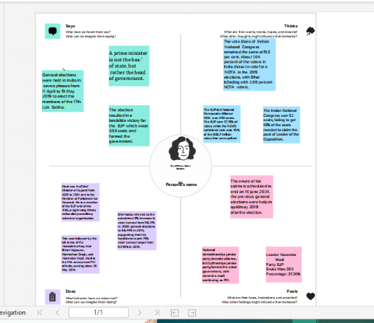
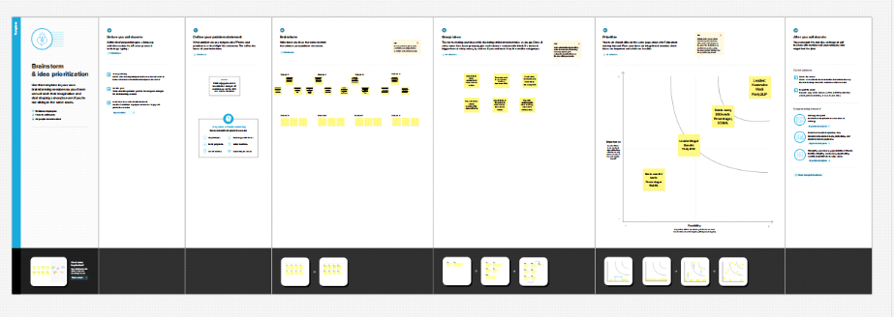
Result
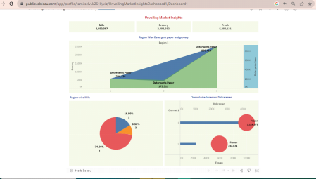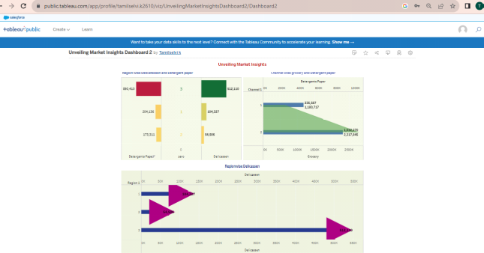

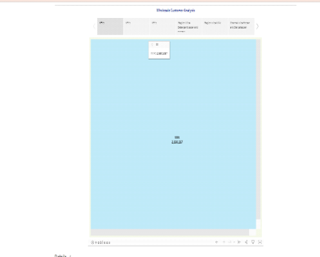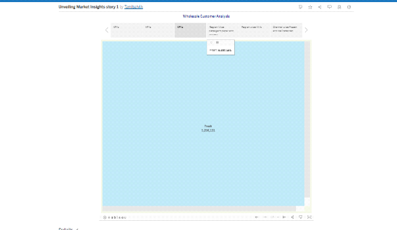
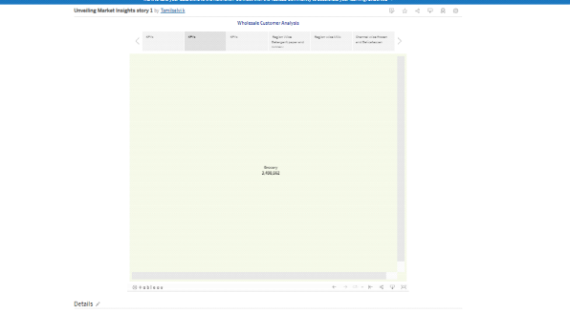

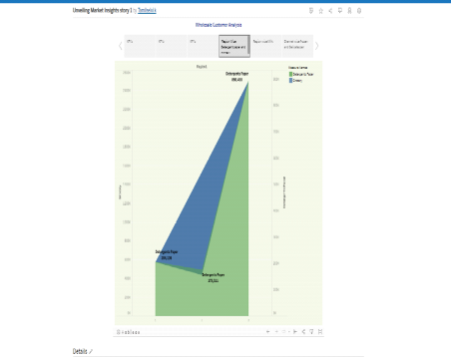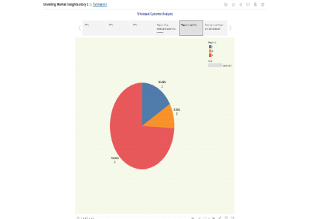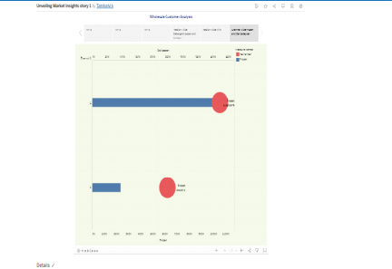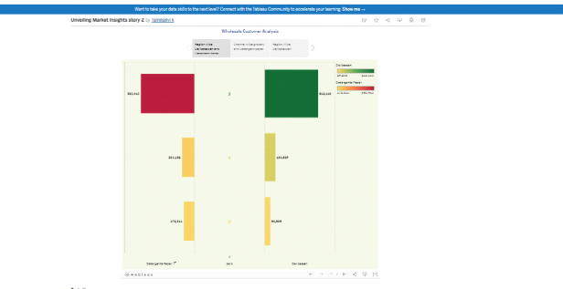

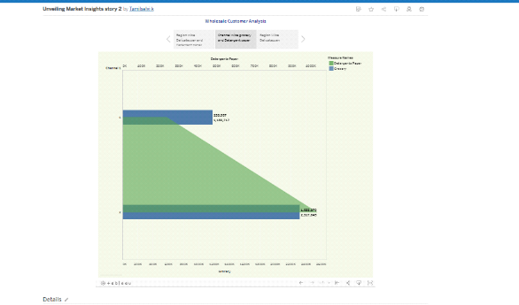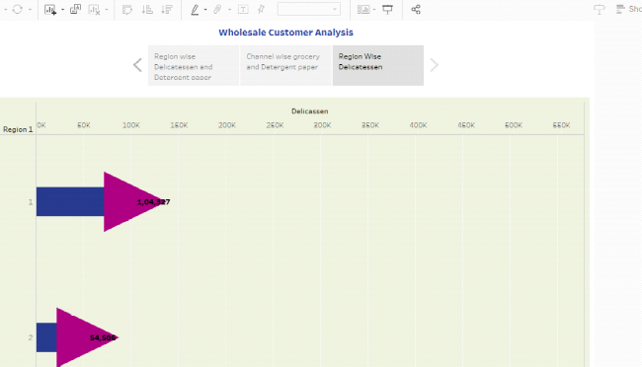

4 Advantages & Disadvantages
• Strategic Decision- making:
Informed decisions based on accurate market insights lead to more effective strategies
and resource allocation.
• Customer -Centric Approach:
Understanding Spending behaviour helps in tailoring products and services to meet
customer needs, improving customer satisfaction and loyalty.
• Competitive Edge:
Insights into market trends and consumer behavior provide a competitive advantage by
allowing a company to stay ahead of competitors
• Innovation opportunities:
Identifying gaps and emerging trends can lead to innovative product or service ideas,
positioning a business as an industry leader
Disadvantages:
• Cost and resources intensive:
Conducting comprehensive market research can be expansive and time-consuming,
especially for smaller businesses with limited resources.
• Data Accuracy Challenges:
Ensuring accurate and reliable data can be difficult, potentially leading to incorrect
assumptions and flawed strategies.
• Rapidly changing markets:
Markets can evolve quickly, rendering collected data outdated or irrelevant, necessitating
continuous research efforts.
• Overreliance on data:
Relying solely on data may overlook qualitative factors or emerging trends that could be
crucial for decision- making
5 Applications
Analysing market insights and spending behaviour can help identify growth opportunities for various applications, such a product development, marketing stratagies, and resource allocation. if you have specific questions or need assistance in a particular area, please feel free to ask for more detailed guidance.
6 conclusion
Market Insights :Start by gathering data and conducting market research to understand the
current landscape and trends.
• Analysing spending behaviour: Use data analytics to examine consumer spending patterns,
preferences, and behaviours.
• Opportunities for growth :
Based on your analysis, pinpoint areas where your business can expand or optimize to meet
market demands.
• Conclusion : Summarise your finding, insights, and growth opportunities, providing a clear path forward for your business

